💄 GlamMatch
Personalized Styling & Salon Connector App

Software Engineering — Sprint 1 Report
Deliverable #2 — Iteration 1
Group Members
Name | Roll Number
Anoushay Fatima | 24L-2585
Eman Adil | 24L-2589
Ayza Ahmed | 24L-2577
Date of Submission: March 24, 2026
Subject: Software Engineering

1. Project Title & Introduction

1.1 Project Title
GlamMatch — Personalized Styling & Salon Connector App

1.2 Introduction
GlamMatch is a web-based styling assistant that provides personalized color, wardrobe, and makeup recommendations based on a user's skin tone, undertone, body type, and face shape. The platform also functions as a salon discovery and appointment booking system, connecting users with nearby beauty parlors.
Sprint 1 focuses on the Core Styling System: user account creation and authentication, the undertone quiz, personalized color palette generation, basic styling suggestions, and body type assessment. This module forms the foundational user journey before introducing photo-based analysis and the salon connector in subsequent sprints.

2. Sprint 1 Backlog

2.1 Module Name
Core Styling System (Quiz + Basic Profile)

2.2 Sprint Goal
Enable a new user to register an account, complete the undertone and body type quizzes, and receive a personalized color palette with basic styling suggestions — all stored on their profile.

2.3 User Stories Selected for Sprint 1
The following five user stories were selected for Sprint 1:
US # | Story ID | User Story Title | Priority
1 | US-01 | Create user account and login | Must Have
2 | US-02 | Take undertone quiz | Must Have
3 | US-03 | Get personalized color palette | Must Have
4 | US-04 | Receive basic styling suggestions based on undertone | Should Have
5 | US-05 | Complete body type questionnaire and receive styling insights | Should Have

3. User Stories (Full Templates with Sub-Stories)

US-01: Create User Account and Login
Field | Description
Story ID | US-01
As a… | new visitor to the GlamMatch platform
I want to… | create a personal account and log in securely
So that… | I can save my styling results, preferences, and booking history
Acceptance Criteria | 1. User can register with name, email, and password 2. Password must be at least 8 characters with one number 3. Duplicate email addresses are rejected with an error message 4. Upon successful registration, user is redirected to the Home screen 5. Registered user can log in with correct credentials 6. Incorrect credentials display a clear error message 7. A 'Forgot Password' link is visible on the login screen
Priority | Must Have
Story Points | 5
Sub User Stories — US-01
Sub-Story | Title | Description
US-01a | Registration Form | As a new user, I want to fill a sign-up form with my name, email, and password so I can create my account.
US-01b | Email Validation | As a new user, I want the system to verify that my email format is valid and not already registered, so duplicate accounts are prevented.
US-01c | Secure Login | As a returning user, I want to log in using my registered email and password, and see a helpful error message if the credentials are wrong.
US-01d | Password Recovery | As a user who forgot their password, I want a 'Forgot Password' option to reset my credentials via email link.

US-02: Take Undertone Quiz
Field | Description
Story ID | US-02
As a… | logged-in user who prefers not to upload a photo
I want to… | answer a short interactive quiz about my vein color, sun reaction, and jewelry preference
So that… | the system can accurately determine my skin undertone (warm / cool / neutral) without requiring a photo
Acceptance Criteria | 1. Quiz consists of 5–7 multiple-choice questions 2. Each question is displayed one at a time with progress indicator 3. User can go back and change a previous answer 4. On completion, system classifies undertone as warm, cool, or neutral 5. Classification is stored in user profile 6. Result summary screen is displayed after quiz completion
Priority | Must Have
Story Points | 5
Sub User Stories — US-02
Sub-Story | Title | Description
US-02a | Question Navigation | As a user, I want to see one quiz question at a time with a progress bar so I know how many questions remain.
US-02b | Answer Selection | As a user, I want to select an option and be able to revisit and change a previous answer before submitting the quiz.
US-02c | Undertone Classification | As a user, I want the system to analyze my answers and classify my undertone as warm, cool, or neutral with a short explanation.
US-02d | Result Persistence | As a user, I want my undertone result to be saved to my profile so I do not need to retake the quiz on every visit.

US-03: Get Personalized Color Palette
Field | Description
Story ID | US-03
As a… | user whose undertone has been determined (via quiz or photo)
I want to… | receive a personalized color palette showing recommended clothing and makeup colors, along with colors to avoid
So that… | I can make informed fashion and beauty choices that genuinely suit my complexion
Acceptance Criteria | 1. Palette displays recommended colors as visual swatches with hex codes 2. Palette also shows colors to avoid with brief explanations 3. Palettes are derived from the detected undertone category 4. User can save or share their palette 5. Palette is categorized into Clothing Colors and Makeup Shades 6. Colors are shown with descriptive names (e.g., 'Dusty Rose', 'Olive Green')
Priority | Must Have
Story Points | 8
Sub User Stories — US-03
Sub-Story | Title | Description
US-03a | Swatch Display | As a user, I want to see a visual grid of recommended color swatches with their names and hex codes so I can identify them for shopping.
US-03b | Colors to Avoid | As a user, I want to see a separate section showing colors I should avoid, with brief reasons, so I can make better purchasing decisions.
US-03c | Category Separation | As a user, I want clothing and makeup color palettes displayed separately so I can reference each category independently.
US-03d | Save Palette | As a user, I want to save my palette to my profile so I can revisit it without regenerating it.

US-04: Receive Basic Styling Suggestions Based on Undertone
Field | Description
Story ID | US-04
As a… | user who has received their color palette
I want to… | receive text-based styling tips covering clothing styles, fabric choices, and accessories that complement my undertone
So that… | I can build a wardrobe and makeup routine that enhances my natural complexion
Acceptance Criteria | 1. Suggestions are tailored to warm, cool, or neutral undertones 2. Tips cover at least three categories: clothing style, makeup approach, accessories 3. Suggestions are displayed in readable card format 4. Tips are distinct for each of the three undertone types 5. User can bookmark individual tips
Priority | Should Have
Story Points | 5
Sub User Stories — US-04
Sub-Story | Title | Description
US-04a | Clothing Tips | As a user, I want clothing style tips (e.g., fabric types, patterns) tailored to my undertone so I can shop more confidently.
US-04b | Makeup Tips | As a user, I want makeup approach tips (foundation tone, lip shades) for my undertone to avoid mismatched products.
US-04c | Accessories Tips | As a user, I want accessory suggestions (jewelry metals, bag colors) that complement my undertone.
US-04d | Bookmarking Tips | As a user, I want to bookmark specific tips so I can quickly access my favorite advice from my profile.

US-05: Complete Body Type Questionnaire
Field | Description
Story ID | US-05
As a… | user who has completed the undertone quiz
I want to… | answer a short questionnaire about my body measurements and proportions
So that… | the system can identify my body type and provide targeted clothing shape and cut recommendations
Acceptance Criteria | 1. Questionnaire covers shoulder, waist, and hip proportion questions 2. System classifies result as one of: Hourglass, Pear, Apple, Rectangle, or Inverted Triangle 3. Result screen shows body type name with description and illustration 4. Clothing recommendations (cuts, silhouettes) are shown based on body type 5. Result is stored in user profile 6. User can retake the questionnaire to update their profile
Priority | Should Have
Story Points | 5
Sub User Stories — US-05
Sub-Story | Title | Description
US-05a | Proportion Questions | As a user, I want to answer descriptive questions about my shoulder-to-hip ratio so the system can determine my body shape without needing actual measurements.
US-05b | Body Type Classification | As a user, I want to see my classified body type (e.g., Hourglass) with a friendly description and a simple illustration.
US-05c | Clothing Shape Advice | As a user, I want to receive clothing cut recommendations (e.g., A-line skirts, wrap dresses) tailored to my body type.
US-05d | Retake Option | As a user, I want to retake the body type questionnaire at any time to update my profile if my body shape has changed.

4. Structured Specifications

Four detailed structured specifications are provided below for the selected user stories.

SS-01: User Registration (US-01a)
Attribute | Detail
Use Case Name | User Registration
Use Case ID | UC-01
Actor(s) | New User, System
Description | A new visitor creates a GlamMatch account by entering their name, email address, and password. The system validates input, creates the account, and redirects the user to the Home screen.
Pre-conditions | 1. User has navigated to the Create Account screen. 2. User has not previously registered with this email address.
Main Flow (Basic Path) | 1. User opens the Create Account screen. 2. User enters full name, email address, and password. 3. User clicks 'Sign Up'. 4. System validates: email format, password length (≥8 chars, ≥1 digit), no duplicate email. 5. System creates user record in the database. 6. System sends a welcome email. 7. System redirects user to the Home screen.
Alternative Flows | A1 — Email already exists: System displays 'This email is already registered. Please log in or use a different email.' and clears the email field. A2 — Weak password: System shows inline error 'Password must be at least 8 characters and contain one number.' A3 — Invalid email format: System shows inline error 'Please enter a valid email address.'
Post-conditions | A new user account is created. The user is authenticated and redirected to the Home screen.
Exceptions | E1 — Database unavailable: System displays a generic error message and logs the incident. User is prompted to try again.
Business Rules | BR1: Email addresses must be unique across the system. BR2: Passwords are stored as bcrypt hashes; plaintext passwords are never stored. BR3: Account creation is free; no payment required.

SS-02: Undertone Quiz Completion (US-02c)
Attribute | Detail
Use Case Name | Undertone Quiz Completion
Use Case ID | UC-02
Actor(s) | Logged-in User, System
Description | The user answers a 6-question quiz about physical traits (vein color, sun reaction, preferred jewelry, neutral preference, eye color, natural hair color). The system scores responses and classifies undertone as Warm, Cool, or Neutral.
Pre-conditions | 1. User is logged in. 2. User has navigated to the Style Analysis screen. 3. User has selected 'Undertone Quiz' option.
Main Flow (Basic Path) | 1. System displays Question 1 (vein color) with options and a progress indicator (1/6). 2. User selects an answer and clicks 'Next'. 3. Steps 1–2 repeat for all 6 questions. 4. User clicks 'See My Results' on the final question. 5. System calculates undertone based on weighted scoring algorithm. 6. System displays result screen: undertone label, icon, and explanation paragraph. 7. System saves undertone to user profile.
Alternative Flows | A1 — User clicks 'Back': System returns to the previous question, retaining the previously selected answer. A2 — User skips a question: System disables 'Next' button and shows inline prompt 'Please select an answer to continue.'
Post-conditions | User's undertone (Warm / Cool / Neutral) is stored in their profile. User is shown the result summary screen.
Exceptions | E1 — Session timeout mid-quiz: System prompts user to log back in. Quiz progress is partially saved (answers given so far are retained).
Business Rules | BR1: A user must answer all 6 questions before seeing the result. BR2: If scores are tied between warm and cool, classification defaults to Neutral. BR3: User may retake the quiz; the new result overwrites the previous one.

SS-03: Personalized Color Palette Generation (US-03a, US-03b)
Attribute | Detail
Use Case Name | Color Palette Generation
Use Case ID | UC-03
Actor(s) | User (with determined undertone), System
Description | After undertone determination, the system generates two structured palettes: a Clothing Color Palette and a Makeup Shade Palette. Each palette shows recommended colors and colors to avoid.
Pre-conditions | 1. User is logged in. 2. Undertone has been determined (via quiz or photo upload).
Main Flow (Basic Path) | 1. System retrieves user's undertone from the profile. 2. System looks up the predefined palette database for the undertone category. 3. System renders 'Clothing Colors' tab: 8–10 recommended swatches + 4–6 'avoid' swatches, each labeled with name and hex code. 4. System renders 'Makeup Shades' tab: 6–8 recommended shades + 3–4 'avoid' shades. 5. User can toggle between tabs. 6. User taps 'Save Palette' to persist results to profile.
Alternative Flows | A1 — Undertone not yet determined: System prompts 'Complete the Undertone Quiz to generate your palette' with a direct link to the quiz.
Post-conditions | Palette is displayed to the user. If saved, it is persisted to the user profile and accessible from the Home screen.
Exceptions | E1 — Palette database entry missing for a specific undertone: System logs error and displays a fallback generic palette with a notice.
Business Rules | BR1: Each undertone category has a distinct predefined palette curated by a styling expert. BR2: Color swatches display both the color name and hex code for accessibility. BR3: The 'avoid' section must include a brief reason (e.g., 'Cool-toned blues can make warm complexions appear dull').

SS-04: Body Type Classification and Recommendations (US-05b, US-05c)
Attribute | Detail
Use Case Name | Body Type Classification
Use Case ID | UC-04
Actor(s) | Logged-in User, System
Description | The user answers a short questionnaire about shoulder width, waist definition, and hip proportion. The system classifies the body type and provides clothing shape and silhouette recommendations.
Pre-conditions | 1. User is logged in. 2. User has navigated to 'Body Type Assessment' from the Style Analysis screen.
Main Flow (Basic Path) | 1. System presents 5 proportion questions (shoulder vs. hips, waist definition, etc.). 2. User answers all 5 questions and clicks 'Get My Body Type'. 3. System applies classification logic and returns one of: Hourglass, Pear, Apple, Rectangle, Inverted Triangle. 4. System displays result card: body type name, icon/illustration, and description. 5. System displays 4–6 clothing recommendations (silhouettes, cuts to favor and avoid). 6. Result is saved to user profile.
Alternative Flows | A1 — User selects 'Retake': System resets the questionnaire and allows user to re-enter answers. Previous result is overwritten upon new submission.
Post-conditions | Body type is saved to user profile. Clothing recommendations are stored and accessible from the profile's styling summary page.
Exceptions | E1 — Ambiguous results (equal scores across two body types): System defaults to the type that scored highest on the first tie-breaking question (shoulder-to-hip ratio).
Business Rules | BR1: There are exactly 5 classified body types in the system. BR2: Recommendations must include both 'styles to try' and 'styles to avoid' for each body type. BR3: The system does not use actual measurements; classification is based on descriptive self-reported proportion comparisons only.

5. Scrum Board — Trello Snapshots

The sprint backlog was managed on Trello throughout Sprint 1. Three snapshots were taken to reflect the progression of tasks.

Snapshot 1 — Sprint Start (Backlog Loaded)
All user stories and sub-tasks were added to the Trello board under 'To Do' at the beginning of Sprint 1.
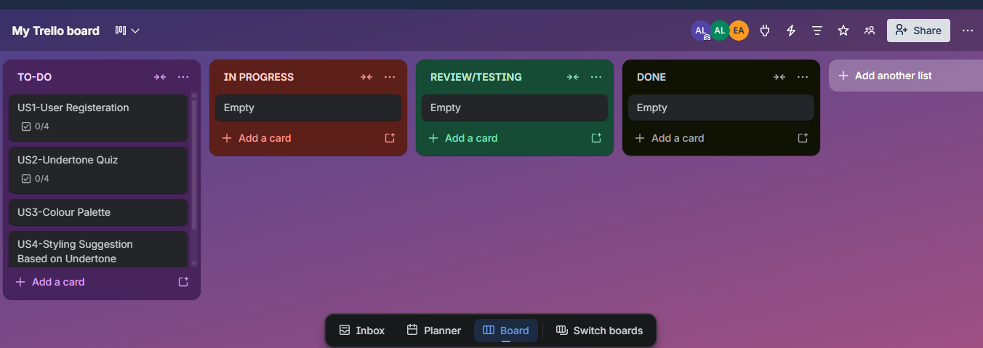

Snapshot 2 — Mid Sprint (Half Tasks Completed)
US-01 (Registration & Login) was completed and moved to Done. US-02 (Undertone Quiz) was in progress.
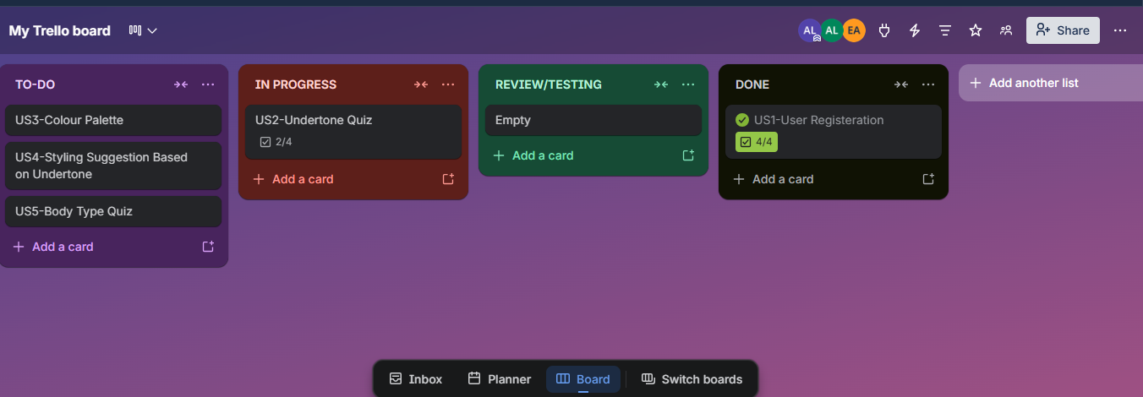

Snapshot 3 — Sprint End
All user stories are completed
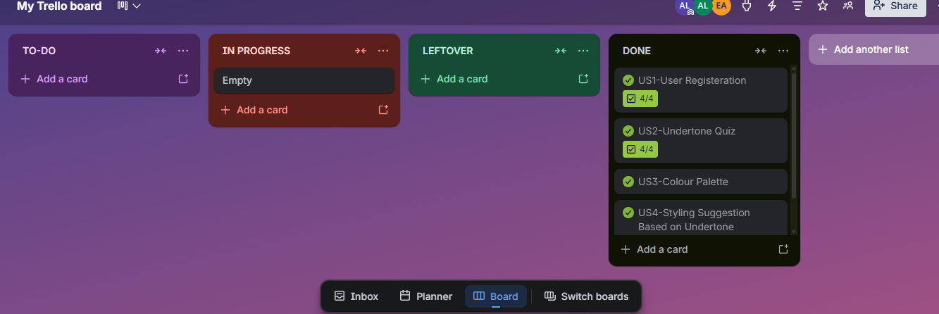

6. Non-Functional Requirements (NFR) — Natural Language Specification

6.1 Performance
The system shall load the quiz screen and color palette results within 3 seconds on a standard broadband connection (10 Mbps). The login and registration API calls shall respond within 1.5 seconds under normal server load.

6.2 Security
All user passwords shall be hashed using bcrypt with a minimum salt round of 10 before being stored in the database. No plaintext passwords shall ever be persisted or logged. User sessions shall be managed via JWT tokens with a maximum validity of 24 hours; tokens shall be invalidated upon logout. All data in transit shall be encrypted using TLS 1.2 or higher.

6.3 Usability
The application shall be designed for users with no technical background. All quiz questions shall be written in plain, jargon-free language. Color palettes shall include both color names and hex codes to support users with varying levels of color knowledge. The application shall comply with WCAG 2.1 AA contrast guidelines to ensure accessibility for users with visual impairments.

6.4 Reliability & Availability
The web application shall maintain an uptime of at least 99% per month excluding scheduled maintenance windows. In the event of a database error during quiz submission, the system shall display a user-friendly error message and shall not lose user responses that were entered prior to the error.

6.5 Scalability
The backend API shall be designed in a stateless manner to support horizontal scaling. The database schema shall support at least 10,000 concurrent registered users without requiring structural changes in the first production release.

6.6 Privacy
The system shall not collect or store any biometric data beyond what is necessary for undertone and body type classification. Quiz responses and styling results shall only be accessible to the account holder. Users shall have the right to delete their account and all associated data at any time.

6.7 Maintainability
All API endpoints shall follow RESTful conventions and be documented using OpenAPI (Swagger) specifications. Frontend components shall be modular and reusable. The codebase shall maintain at least 70% unit test coverage for core business logic modules (quiz scoring, palette generation).

8. Iteration 1 — Implementation Overview

The following screens were implemented or prototyped as part of Sprint 1. Implementation screenshots are to be inserted here from the actual deployed or prototype application.

8.1 Screen: Login / Registration
The Login screen allows existing users to enter their email and password. The Create Account screen provides fields for name, email, password, and confirm password. Validation errors are displayed inline below each field. Upon successful registration, the user is redirected to the Home screen.
[SCREENSHOT PLACEHOLDER — Login Screen]
[SCREENSHOT PLACEHOLDER — Create Account Screen]

8.2 Screen: Home / Dashboard
After login, the user lands on the Home screen which displays quick-action cards: 'Start Style Analysis' and 'Find a Salon'. The user's name is shown in the top navigation bar. The styling progress summary shows quiz completion status.
[SCREENSHOT PLACEHOLDER — Home Screen]

8.3 Screen: Undertone Quiz
The undertone quiz presents one question at a time with a progress indicator at the top. Each question has 2–4 answer options presented as selectable cards. A 'Back' button is visible for navigation. Upon completion, the result screen displays the undertone classification with an icon and explanation.
[SCREENSHOT PLACEHOLDER — Quiz Question Screen]
[SCREENSHOT PLACEHOLDER — Quiz Result Screen]

8.4 Screen: Color Palette
The color palette screen displays two tabs: 'Clothing Colors' and 'Makeup Shades'. Each tab shows a grid of color swatches with their names and hex codes. A separate 'Colors to Avoid' sub-section is displayed below the recommended colors.
[SCREENSHOT PLACEHOLDER — Color Palette Screen]

8.5 Screen: Body Type Questionnaire
The body type questionnaire uses descriptive proportion questions with illustrated option cards. Upon completion, the result screen shows the classified body type (e.g., Hourglass) with a simple body outline illustration and clothing recommendations listed below.
[SCREENSHOT PLACEHOLDER — Body Type Quiz Screen]

9. Work Division

Member | Role | Sprint 1 Contributions
Ayza Ahmed(24L-2577) | Project Lead + Requirements Engineer | Sprint planning, user story writing, structured specifications (SS-01, SS-02), NFR documentation, sprint backlog setup on Trello, burn-down chart, report compilation and formatting.
Eman Adil (24L-2589) | Backend + Database Developer | Database schema design (User, QuizResponse, Palette tables), API development (registration, login, quiz submission, palette generation endpoints), JWT authentication implementation, quiz scoring algorithm.
Annushay Fatima (24L-2585) | Frontend Developer + UI/UX + QA Tester | UI design and implementation of Login, Registration, Home, Quiz, Palette, and Body Type screens, structured specifications (SS-03, SS-04), test case writing for US-01 through US-03, Trello snapshot management.

GlamMatch — Sprint 1 Report | Software Engineering | March 2026

